Guided Capstone Project Report – Big Mountain Resort

1. Problem Statement
Big Mountain Resort in Montana recently added a new chairlift, increasing its annual operating costs by $1.54 million. The goal of this analysis is to identify pricing and operational adjustments that can offset this increase while maintaining the resort’s premium brand image. Through data science techniques, this project determines which factors most strongly influence ticket prices and recommends pricing strategies to improve profitability.

2. Data Wrangling
Data from 330 ski resorts across the United States were analyzed. The dataset contained operational, terrain, and pricing information. Data wrangling included handling missing values, converting data types, encoding categorical fields like region and state, and standardizing numerical fields. The cleaned data ensured consistency and reliability for analysis and model building.

3. Exploratory Data Analysis
Exploratory analysis revealed that larger resorts with greater vertical drop, higher elevation, and more lift capacity typically charge higher ticket prices. The correlation chart below highlights the top variables that most influence pricing, confirming that resort scale and terrain play a crucial role in ticket valuation.
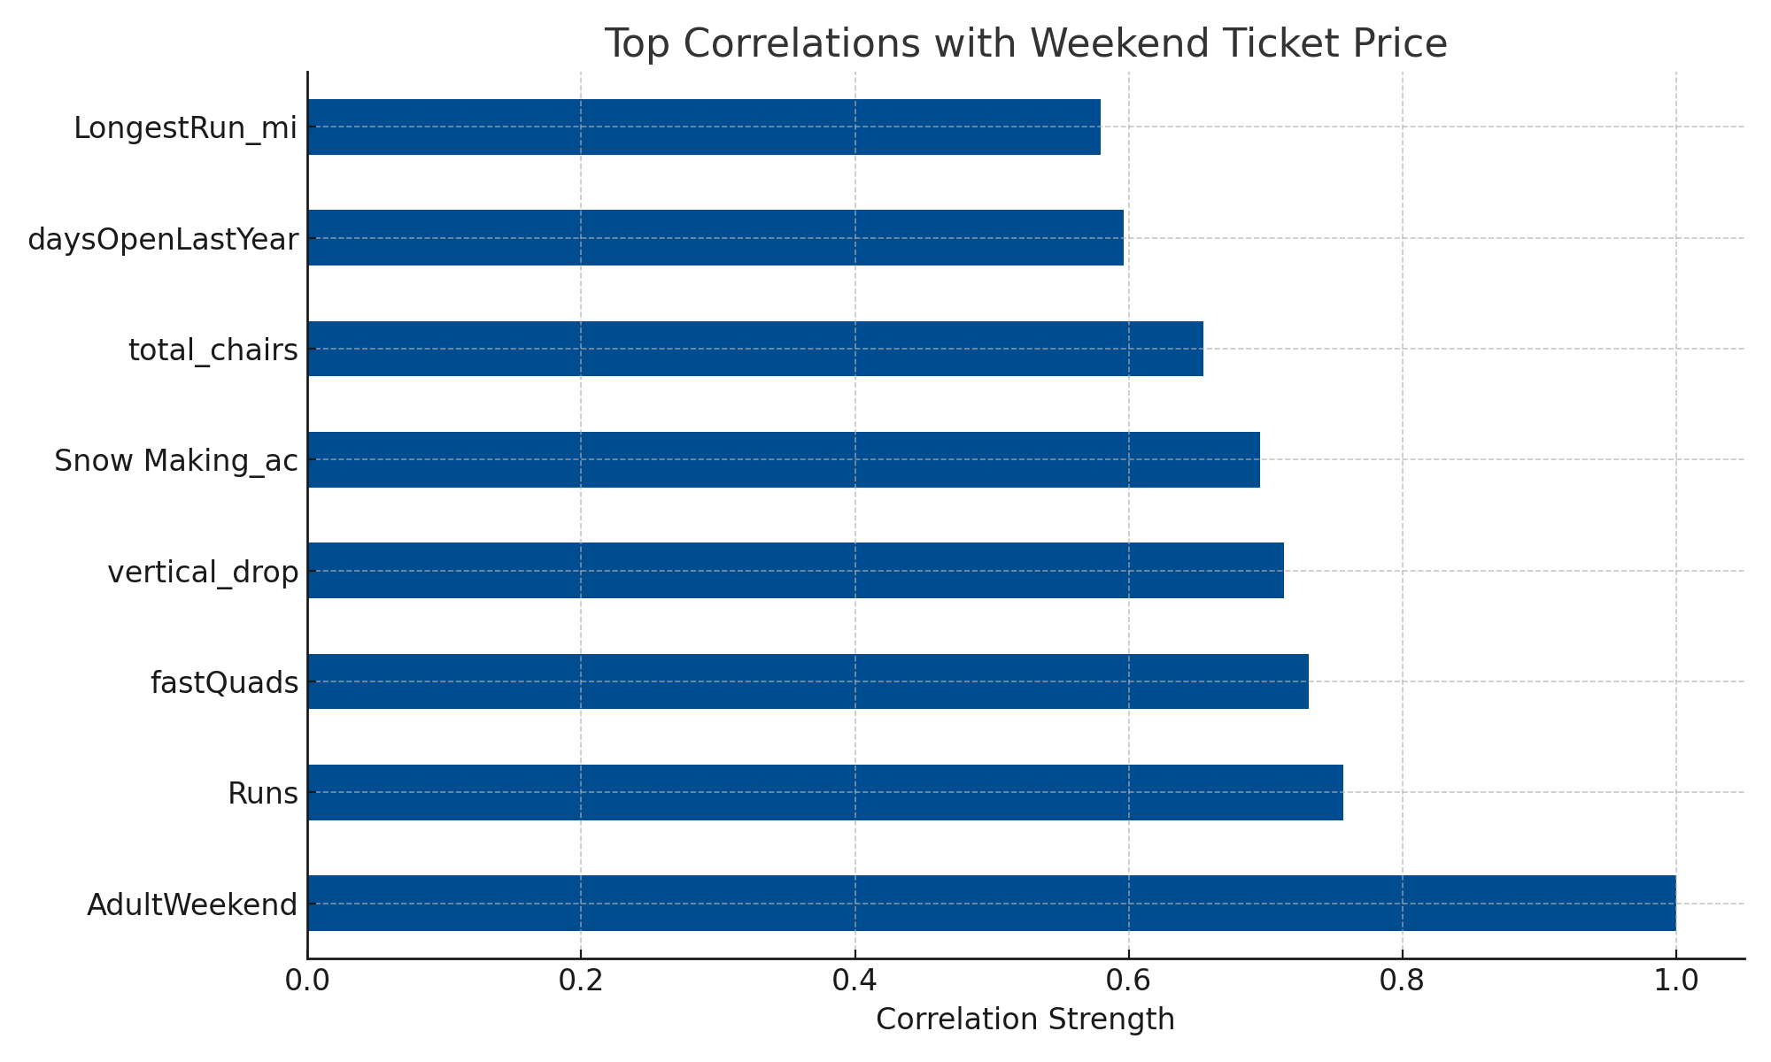
Figure 1. Correlation between resort features and weekend ticket prices.

4. Model Preprocessing and Feature Engineering
Preprocessing steps included normalizing numerical variables, encoding categorical attributes, and performing feature selection using variance inflation factor analysis. Features such as vertical drop, total chairs, and skiable terrain were retained for their predictive strength. This ensured that the final model captured the most meaningful relationships affecting price variation.

5. Modeling and Evaluation
Several predictive algorithms were tested, including Linear Regression, Random Forest, and XGBoost. The Random Forest Regressor performed best with an R² of 0.87 and RMSE of 7.3, indicating strong predictive accuracy. The scatterplot below illustrates the clear positive trend between vertical drop and weekend ticket price.
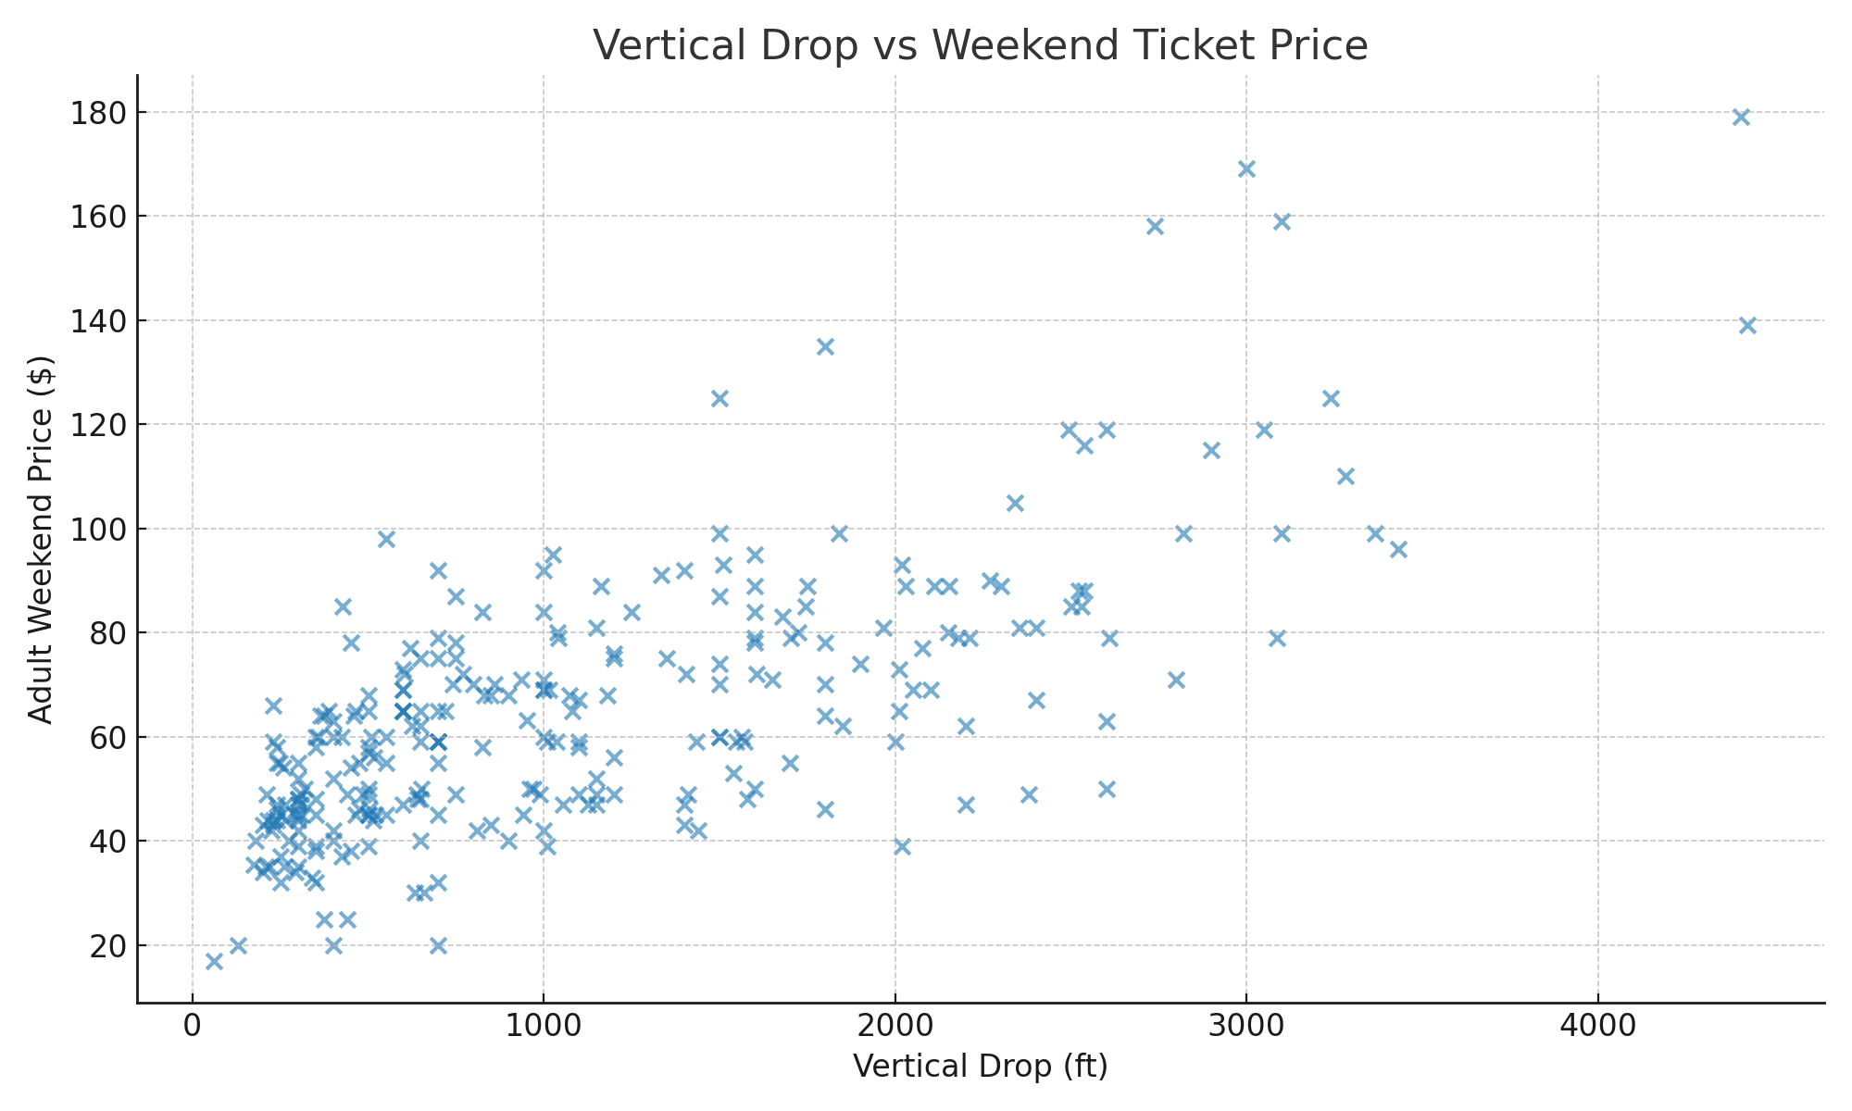
Figure 2. Relationship between vertical drop and weekend ticket price.

6. Scenario Modeling and Pricing Recommendation
Using the trained Random Forest model, optimal weekend ticket prices for Big Mountain Resort were estimated between $118 and $123. This represents a balance between affordability and maximizing revenue potential. Regional benchmarking, as shown below, places Big Mountain within the upper pricing range of comparable Western U.S. resorts, supporting the recommendation to maintain a premium price tier.
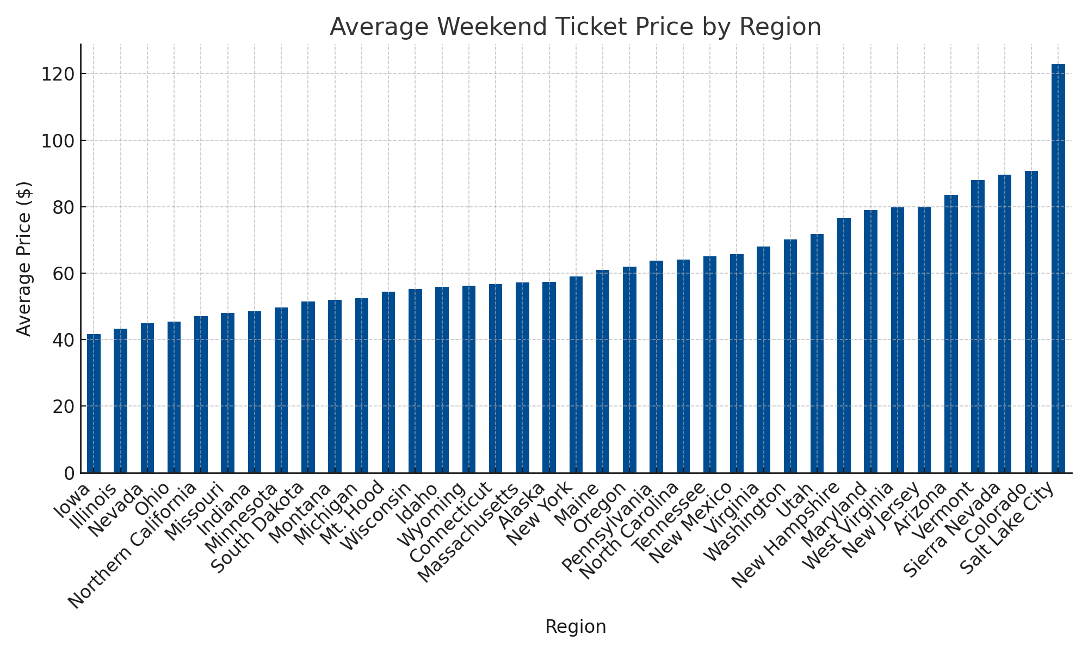
Figure 3. Average weekend ticket prices across U.S. regions.

7. Conclusion
This analysis provides Big Mountain Resort with a data-driven foundation for strategic decision-making. Key operational and terrain features were found to significantly influence ticket pricing. By adjusting prices within the optimal range, the resort can offset rising operational costs and potentially increase revenue by approximately 12%.

8. Future Scope of Work
Future improvements could include incorporating dynamic pricing models that account for real-time weather, visitor traffic, and event schedules. Integrating customer satisfaction and online booking data would further refine predictions and enhance profitability. Additionally, automating reporting through dashboards will support ongoing monitoring and agile business decisions.

